DTSC 671: AI Solutions in the Cloud

Recommending Drinks Prototype
with Amazon Personalize

Goal
Starbucks’ data science team wants to create a cloud-based solution to recommend drinks to customers based on their past purchase history. The goal is to use machine learning to personalize the customer experience by suggesting drinks they are most likely to enjoy.

In this assignment, you will create a recommendation system with Amazon Personalize and test the system. We call this assignment a “prototype”, because we will focus only on setting up the recommendation system, not creating an architecture like previous assignments.

You will submit the template with the requested screenshots on Brightspace. Please note you only have one submission attempt.

Pricing Estimate
The following estimate shows the costs you may incur on your AWS personal account.

AWS Pricing Estimate
Service | Calculation | Cost
S3 Standard Storage | You will store a CSV file in one bucket and have a CSV file as output in another bucket.  These will be very small fill sizes. The customer_orders CSV is 49 KB.  S3 Standard pricing is roughly $0.023 per GB per month (varies slightly by region).  49 KB = 0.000049 GB  0.000049 GB x ($0.023) = $0.000000138 | < $0.01
Personalize | Personalize  - Training: $0.24/hr  - Roughly 2 hours of training  - Campaign: $0.15 per 1,000 Recommendation Requests  - With Transaction Per Second (TPS) set at 1  - Assuming 2 hours (i.e., 7200 seconds)  Training: $0.50  Real Time Inferences (from Campaign): $1.08  Total Estimate: $0.50 + $1.08 = $1.58 | $1.58

Directions
Make sure that all your services are in the same region (e.g., us-east-1)
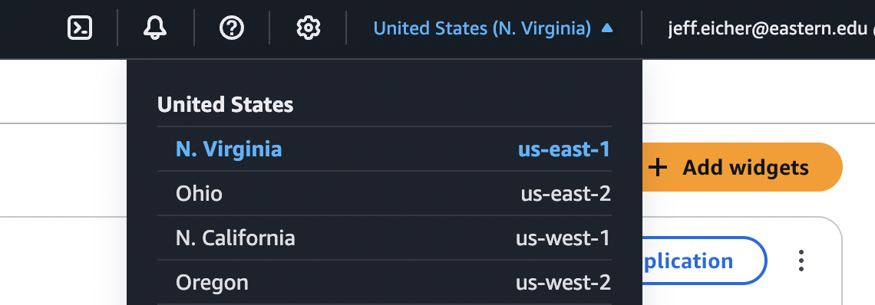

STEP 1: Import the customer orders CSV to S3 bucket
- Navigate to Brightspace and download customer_orders.csv in this assignment’s folder.
- Create an S3 bucket named dtsc-671-personalize-input-<term>-<year>-<name>
  - For example, dtsc-671-personalize-input-fa1-2025-jeffeicher
  - Include tags for cost tracking, such as key: dtsc-671, value: personalize
- Import the customer_orders.csv dataset to the input S3 bucket.
- Create a bucket policy allowing Amazon Personalize access to the bucket.

STEP 2: Create an IAM policy and role
- Create an IAM policy with access to Amazon Personalize and the S3 bucket you created above.
- Create an IAM role with the above IAM policy attached.

STEP 3: Create a dataset group, create interactions schema, load interactions data
- Note: You can use AWS CLI on CloudShell or the management console to complete the following steps.
- Open Amazon Personalize in the AWS Console
- Create a dataset group named: dtsc-671-drink-recs-<yourname>
  - For example, dtsc-671-drink-recs-jeffeicher
- Write the JSON schema (with the help of an LLM) for the interactions data.
  - Note: This recommendation system uses only interactions, not users or items.
  - You can name the schema whatever you would like.
- Set the customer_orders.csv as the interactions data.

STEP 4: Create a dataset group, solution, and campaign in Amazon Personalize
Recommendation: Do not create the solution or the campaign until you can actively manage it and you have time to complete this assignment. The solution takes roughly 30-45 minutes to become active (the campaign is less time). Active solutions and campaigns incur hourly charges.

- Create a solution. Choose the aws-user-personalization-v2 recipe. Name your solution drink-solution-<name>.For example, drink-solution-jeffeicher
  - Caution! Active solutions incur hourly charges. Delete the solution when not in use.
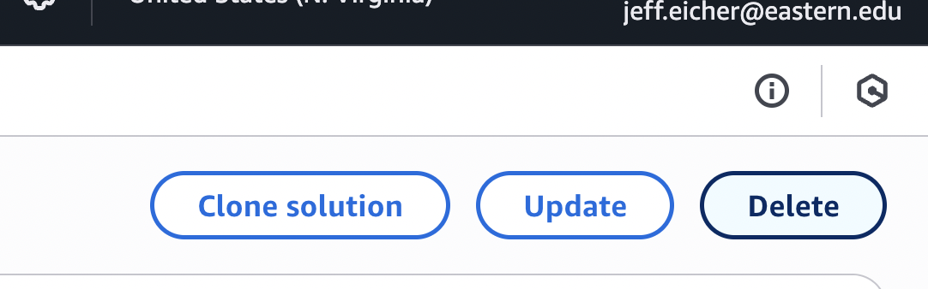

- After training completes, create a campaign using this solution and recipe. Name it drink-campaign-<name>. For example, drink-campaign-jeffeicher
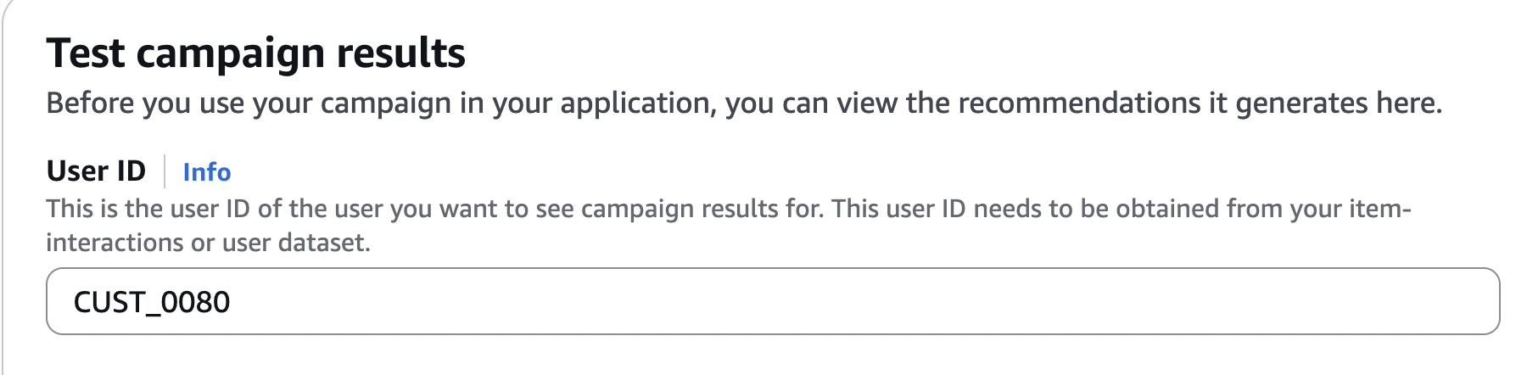
  - Caution! Active campaigns incur hourly charges. Delete the campaign when not in use.
- Remember that solutions and campaigns incur charges:
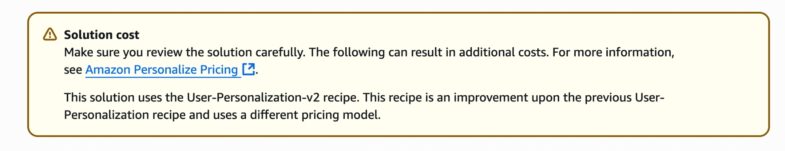

STEP 5 (Test): Upload the customer orders CSV to the input bucket
- Test the campaign for the customer whose ID is CUST_0080.
- Note the list of drink recommendations for this customer.

STEP 6: Brightspace submission
- Submit the assignment template with the requested screenshots.
- Be sure to delete any active solutions and campaigns, as these incur hourly charges.

This is course material that was distributed to students enrolled in DTSC 671 at Eastern University. The materials were made exclusively available to students solely for the purpose of completing the course and are not intended for further distribution or retention beyond the course period. The materials were created by program faculty specifically for use in courses at Eastern University.

